September 9, 2025
INVITATION TO PARTNER
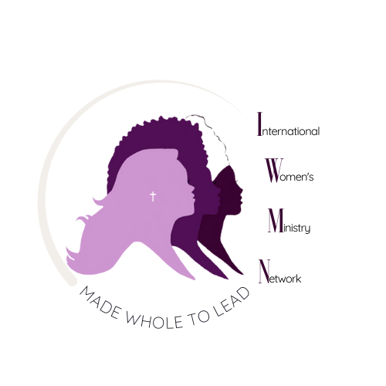

Dear [Pastor/Leader/Organization Name],

Grace and peace to you in the name of our Lord Jesus Christ.

I am writing to invite you into a meaningful partnership with SELAH 2025: A Christian Women’s Retreat for Creative Rest in God’s Presence, happening November 14–15, 2025, in London, Ontario. This retreat is uniquely designed to provide spiritual renewal and practical tools for women leaders, mothers, and professionals who continually pour out in service yet often neglect to pause and be replenished. The International Women’s Ministry Network (IWMN) is the umbrella ministry of SELAH and has walking alongside women in seasons of stress, burnout, and crisis for over 2 decades. We have witnessed the life-changing power of rest in God’s presence in such spaces.

SELAH 2025 will create a sanctuary where women can experience both psychotherapy-informed practices and theology-rooted rhythms of rest—a space of true healing, renewal, and equipping. Here’s where you come in:
Many women, including pastors’ wives, church leaders, and community servants, are facing financial challenges that prevent them from attending. We are seeking sponsorships, donations, and scholarships so that these women can encounter the transformation they desperately need.

Ways to Partner:

- Scholarship a woman in need: $285
- Sponsor the retreat at a greater level: Platinum ($2,500+), Gold ($1,000), Silver ($500), Bronze ($250)
- Make a general donation to help cover retreat costs and extend the reach of this ministry.

How to Give:
- PayPal: paypal.me/iwmn
- Zelle: iwmnfinance@gmail.com
- E-Transfer: mwmn.rmfm@gmail.com
- Zeffy (donations page): https://tinyurl.com/selahsponsorship

Your investment will not only provide access for women who would otherwise be unable to attend, but it will also strengthen the wider church by sending these women back to their families, workplaces, and ministries rested, grounded, and renewed in Christ. We would be honored to have your church/organization stand with us in making SELAH 2025 a safe haven of transformation for women leaders.

With gratitude for your partnership in the Kingdom,
On behalf of the International Women’s Ministry Network (IWMN)
[Your Name]

