September 9, 2025
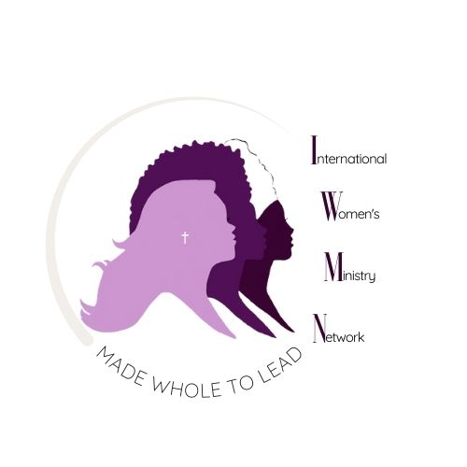
Partner with Me in Attending SELAH 2025

Dear [Friend’s Name],
I hope this note finds you well. I’m writing to share something that is very close to my heart. This November 14–15, I have the opportunity to attend SELAH 2025: A Christian Women’s Retreat for Creative Rest in God’s Presence, happening in London, Ontario.
SELAH is designed especially for women leaders and women who carry many responsibilities—those who pour out constantly but often forget to pause and be poured into. It’s a place where psychotherapy meets the theology of rest, offering both practical tools for grounded living and deep spiritual renewal in God’s presence. I believe this retreat will be life-transformative for me, helping me to return to my daily life refreshed, strengthened, and equipped.
The total cost for registration is $285, plus travel expenses. I would love to attend, but I also recognize I cannot do it alone. That’s why I am reaching out to invite you to prayerfully consider supporting me—whether through a financial gift or through prayer. Every amount, no matter the size, brings me closer to being able to attend.
Here are simple ways you can give if you feel led:
- PayPal: https://www.paypal.com/paypalme/iwmn
- Zelle: iwmnfinance@gmail.com
- E-Transfer: mwmn.rmfm@gmail.com
- Zeffy (donations page): https://tinyurl.com/selahsponsorship
If you could make your gift no later than October 3rd, and put my name in the memo, I would be very grateful. Receipts will be issued for income-tax purposes.
Please know that your gift will not only help me attend but also sow into my spiritual renewal. I am believing that through SELAH, I will come back stronger, rested, and ready to serve others from a deeper well in Christ.
Thank you for considering supporting me in this journey. Your encouragement and generosity mean so much to me.
With love and gratitude,
[Your Name]
For WhatsApp message, or social media post:

✨ Friends, I have an amazing opportunity this fall! ✨
I’ve been invited to attend SELAH 2025: A Christian Women’s Retreat for Creative Rest in God’s Presence (Nov 14–15 in London, Ontario). This retreat is designed to help women leaders like me, pause, be renewed, and return equipped with tools for living grounded in Christ.
The cost is $885, and I’d love your support to help me get there. If you feel led to give, here are simple ways:
💻 PayPal: paypal.me/iwmn
📧 Zelle: iwmnfinance@gmail.com
📧 E-Transfer: mwmn.rmfm@gmail.com
🌐 Zeffy: https://tinyurl.com/selahsponsorship
Your prayers and gifts mean so much—thank you for helping make this possible! 💜

